# *Team Name:* Mean O’Chutoy

## Personal Information

*Team Member:* ***Sean Atherton***

* **Student Number:** S3893785
* **Student Email:** [S3893785@student.rmit.edu.au](mailto:S3893785@student.rmit.edu.au)

I was born in Queensland (Australia), my parents and I moved to Melbourne (Victoria) in 2003, when I was roughly 3 years old. I have spoken English all my life and unfortunately, I do not know how to speak any additional languages, maybe if I ever travel overseas in the future, I’ll try to learn one. I regularly talk with friends online to either play video games together or just to catch up and chat. Before the pandemic I was occasionally going on trips with friends and family throughout Victoria, hopefully, that changes in 2021.

**Team Member: Jack Holliday**

* **Student Number:** S3864772
* **Student Email:** [S3864772@student.rmit.edu.au](mailto:S3864772@student.rmit.edu.au)

My interest in I.T started at a young age, constantly fighting with my brothers for access to the computer… (mostly playing games). It was not until I had finished school and started working when I had obtained the first computer that I could call my own, but I still always had technology around be it phone, social media etc.

I expect to learn a lot about the different pathways within I.T. Working in the industry. That would help build my helpdesk role I have chosen the generalized I.T degree to help broaden my horizons and narrow down what I would like to do.

**Team Member: STEPH NEWLAND**

* **Student Number:** s3904486
* **Student Email:** [s3904486@student.rmit.edu.au](mailto:s3904486@student.rmit.edu.au)

I was born and raised in here in Australia, however, due to my father’s nationality, I am technically half-Australian, half-German. Due to a chronic illness, I completed my ATAR in the year after I was supposed to graduate and have since studied a Bachelor of Creative Industries at ECU. I paused these studies this year to commence at RMIT as I wanted to move into a degree that I thought was better suited to the career I aspire to have in the future. I got my love of technology from my father, who is always tinkering around in his garage, whether it be with his car, a radio, or even our old PlayStation 1. IT has always been something I’ve been interested in, and as I’ve grown older and spent more time developing my skills and passions, I’ve realised it was the industry I wanted to pursue.

**Team Member: Joshua Chuang**

* **Student Number:** s3729939
* **Student Email:** [s3729939@student.rmit.edu.au](mailto:s3904486@student.rmit.edu.au)

Hi, I’m Josh and I am at 21-year-old student currently in my first year studying I.T online at RMIT. I was born and raised in Australia, but my both my folks are from a small island nation called Taiwan. As such I speak both English and Mandarin with the former being the language I most commonly use and the latter being what I mean use to communicate with my parents. I have always enjoyed tinkering with technology and one of the more interesting things about myself is that I enjoy fixing iPhones. The first iPhone I fixed was my iPhone 3G and have experience repairing all iPhones up to the 8th generation. Outside of I.T my main hobby is photography. I have a keen interest in shooting night photography, landscapes, and portraits.

**Team Member: Liam Oloughlin**

* **Student Number:** s3908839
* **Student Email:** [s3908839@student.rmit.edu.au](mailto:s3908839@student.rmit.edu.au)

Hello! I am Liam, I am 20 years old, and I am currently enrolled at RMIT completing some core and foundation subjects to move into a Bachelor of IT. I am full Australian, born and raised here. I have had a passion for gaming ever since I was super young, this sparked a big interest in mostly IT related things, it also helped that my Dads career revolves around IT too. I don’t have to many hobbies outside of gaming, but I do really like to learn languages, Currently I have only learnt Japanese, but I do want to learn more.

**Team Member: Mia Vasiliadis**

* **Student Number:** s3909174
* **Student Email:** [s3909174@student.rmit.edu.au](mailto:s3908839@student.rmit.edu.au)

I was born in Adelaide but moved to Cairns in 2000 when I was less than a year old and lived there for 15 years, before moving back to South Australia. After graduating, I moved to Melbourne in order to pursue higher education study. I have completed a Cert 3 and 4 in Information Technology through TAFE SA, focusing on the Website Development branch. My interest in IT started when I got a PS2 as a kid and wanted to try games on the PC, which led to me building my own when I was 11. Although I was initially interested in hardware and the physical components of IT, it has grown into me wanting to know about every aspect. I spend most of my free time playing games and talking to my friends.

# Team Profile

**Team Member: Sean Atherton**

Myers-Briggs Results

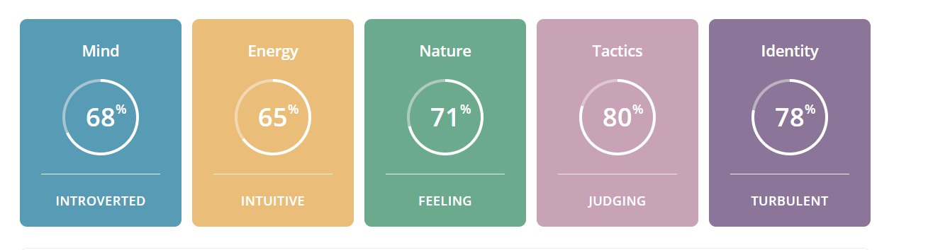

The test results from the Myers Briggs online test class me as an “Advocate” or an INFJ-T, the specific percentages it has supplied are I’m 68% Introverted and 32% Extraverted, 65% Intuitive and 34% Observant, 71% Feeling and 29% Thinking, 80% Judging and 20% Prospecting, and finally 78% Turbulent and 22% Assertive.

Learning Style Test Results

Results indicate that I am both 35% Auditory & Visual, with the additional 30% being tactile. So, I would mainly be classed as an Auditory/Visual, with most of my effective learning been done by hearing, listening, reading, and seeing pictures. Most of the things I remember are things by sight. For example, I often use flashcards and try to visualize things I hear and or read to me.

Creativity and Problem-Solving Test Results

The Snapshot report results indicate that on a scale of 0-100 of openness to creativity I would be a 78. “Therefore, although you won’t immediately reject solutions that have worked in the past, you’d rather not have them be your only option”.

How this information may be helpful to the group.

I believe with my tendency to be more open to ideas and creative solutions will be useful when dealing with the Project Idea and scenarios where problems exist around the way to approach aspects of the content and team.

Taking the results into account when establishing a way to allow myself and the others to play to their strengths I think is the best course of action to take. Although in saying that, the results of these tests are not overly specific in their descriptions and “diagnosis” and are not too entirely accurate, so keeping that in mind and not making assumptions about what everyone can and cannot do when working together based solely on these results is something I can avoid.

**Team Member: Jack Holliday**

Myers-Briggs Results

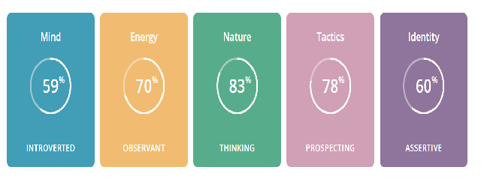

You know at first, I was ignorant of the entirety of these tests. As I find myself reading through, I fit the profile. There are things in this that I have made myself aware of that I could not put to words, that somebody has already done, in a way that makes sense. A virtuoso is someone with Introverted, Observant, Thinking, and Prospecting personality traits. They tend to have an individualistic mindset, pursuing goals without needing much external connection.

Learning Style Test Results

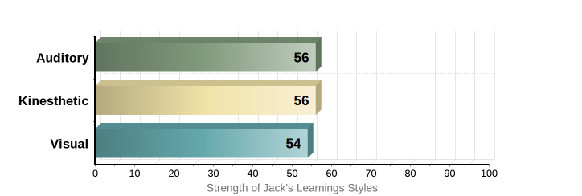

I very much agree with the results received. I am practical through my learning, the quickest and most efficient way to learn something is to “Throw me in the deep end” and most of the time getting my hands on what needs to be done is when I learn the most.

IPIP Big Five Factor Markers

I had completed this test and decided to add it to the mix, it completely contradicts my virtuoso profile, so as for its accountability it is questionable. I had scored high extroversion and emotional stability.

However, everything else had stated that I would be a terrible teammate like the way I would communicate with other team members. I would like to think I have proved it wrong!

How this information may be helpful to the group.

I think with everyone’s information compiled and read gives a good indication of the person you are going to work alongside. Having the knowledge that I like to jump in the thick of things would be beneficial for assisting with someone’s work that has already been created and needs a second opinion.

**Team Member: STEPH NEWLAND**

Myers-Briggs Results

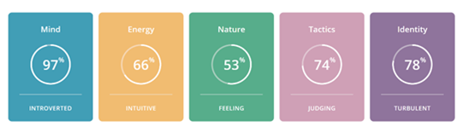

The Myers-Briggs Type Indicator classes my personality type as INFJ-T, or the ‘Advocate.’ Breaking down these results show that I am creative, passionate, principled, and insightful. I always strive to do my best, aiming to discover the perfect solution any problem and am willing to forgo recognition or acceptance to use my strengths to help other succeed. While I can communicate effectively, I strive for constant improvement, reaching for perfection which can lead to obsession and procrastination of other responsibilities. Coupled with a tendency to circumvent criticism to avoid conflict, and the perfectionist obsession, this can lead to burnout if responsibilities are not kept balanced.

Learning Style Test Result

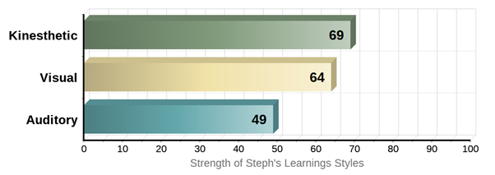

This learning styles test shows that I am mostly a kinesthetic or tactile learner. I learn better when I can create or work with my hands and can complete tasks by being involved through a hands-on learning experience. I also learn well visually, and can recall study more efficiently when I can physically take notes, make charts/posters, or can visualise spoken instruction into the written word.

The Big Five Personality Test (OCEAN model)

The Big Five results show that I am dedicated to my work, have a clear sense of duty and am well organised. I am compassionate, good-natured and prefer cooperation over conflict and competition as also seen in the Myers-Briggs results. While the low extraversion score shows I am quite formal and reserved, preferring to work alone and avoid direct leadership roles, I find that if I am in a group with like-minded individuals, it is much easier for me to communicate. These results are in direct competition with the Myers-Briggs results, but seem to agree with the Learning Styles test.

How this information may be helpful to the group

According to these results, I am likely to purse a path that follow my interests and aligns with my values and ideologies, making it easy to work in a team with others who hold the same interests as my own. To feel fulfilled in my work, I need a sense of independence, however, I have a strong desire to connect and communicate effectively with others to help them excel while reinforcing the team’s leadership, without being a leader myself.

**Team Member: Joshua Chuang**

MBTI Test Results (Top 3)

1. ENTJ – The Commander
2. ENTP – The Inventor
3. INTP – The Architect

Learning Style Test Results:

1. Kinesthetic (40%)
2. Visual (33%)
3. Auditory (27%)

How this information may be of helpful to the group

In terms my behavior on a team, these results would indicate that I would be most likely to be a in strategic leadership position. Because I have scored very high on the emotional intelligence test, specifically in social awareness and relationship management, I am highly likely to pursue a diplomatic approach when dealing with conflict within a group rather than acting with aggression. My high emotional score also means that I can maintain fantastic working relationships with each of my group members through active understanding of their concerns, empathy.

**Team Member: Liam Oloughlin**

Myers-Briggs Results

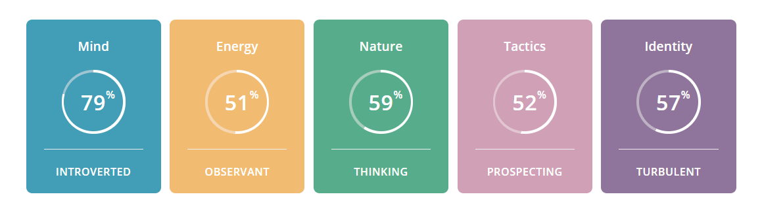

From taking the Myers Briggs personality test, I have been determined as an “ISTP-T, Explorer, Constant Improver”, For this result to be made, a table of Percentages are generated and are put into a personality group. Percentages include, 21% Extraverted – 79% Introverted, 49% Intuitive – 51% Observant, 59% Thinking – 41% Feeling, 48% Judging – 52% Prospecting, 43% Assertive - 57% Turbulent.

Learning Style Test #1 – All-Round

My Learning style test states that I am a “Tactile” learner. Percentages being 30% for both Auditory and Visual, while Tactile sits at 40%. From a line in the Test, it states that I learn very well by **DOING** rather than by Listening, Seeing or Reading. I find hands-on learning to be the most effective for me by far.

Learning Style Test #2 – In Depth

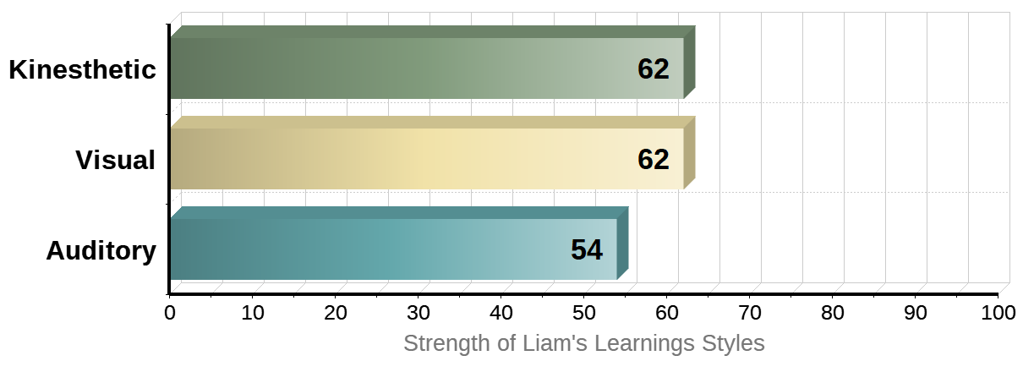

My main two Learning styles are Kinesthetic and Visual. This means that I can learn more efficiently by doing hands-on experience rather than have someone tell me how to do something. I can also learn by using my sight and what's in front of me, which means I can grasp a new concept by watching a video, looking at charts or diagrams. I prefer if material that is spoken is written down or made into an activity to make sure I understand it better.

How this information may be helpful to the group

Based on the information of my results, I would fit more as someone who works at their own pace, while making sure I am not hindering the team in anyway. I also like to not take on any sort of leadership type roles but will step up to helping anyone need be. If someone needs to teach me anything I would want to be taught step-by-step and **DO** each step along with them.

**Team Member: Mia Vasiliadis**

Myers-Briggs Results

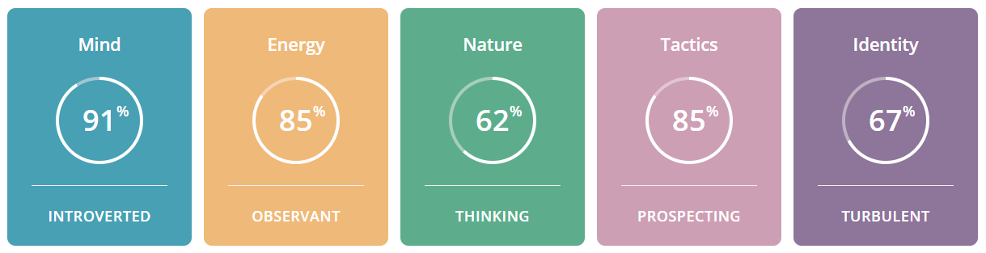

My results of the 16 personalities test state that I am an ISTP-T or ‘Virtuoso’, who are described as people with an individualistic mindset and tend to pursue goals by themselves rather than relying on external connections. ISTPs are reserved but observant, focus on facts and details, make decisions based on logic and prefer spontaneity and flexibility over being planned and organised.

Learning Style Test Result

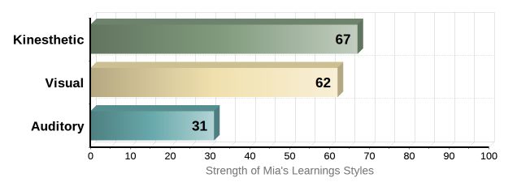

My learning style is primarily Kinesthetic and Visual, which means I like to learn hands on and experiment with problems manually. For instance, instead of looking up a guide on how to fix a broken headset, I would much rather the challenge of taking it apart and learning about it along the way.

How this information may be of helpful to the group

I could see how my learning style and personality could conflict with others in a team setting, as I like to work solo and tackle problems in interesting and challenging ways where others may prefer to take a different route. However, my individualism can also be seen as a positive trait, as my solo work ethic means that I can rely on my own resourcefulness and motivation to get the task ahead done, even if my approach may differ from others. My individualistic traits and self -reliance mean that I have less preference on personality types, provided my group members contribute their parts and offer their ideas. However, I realise that my solo work ethic may affect others with more dependent personality types. I would have to consider others’ ideas and work ethics, be more accepting of these differences and make sure that I can compromise a little of my individualism to maximise my group’s effectiveness.